Press release

Spinder Autolift and Spinder FFS

With pleasure we present our new award winning products Autolift and Feed Front Signalling FFS.

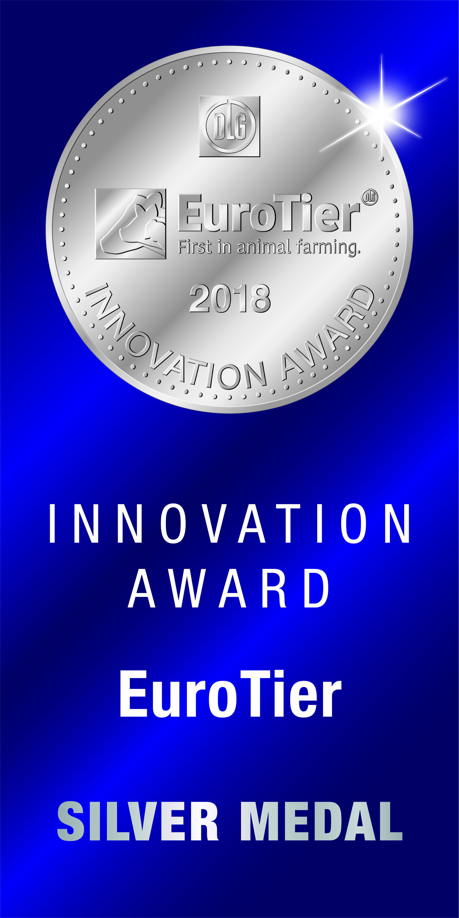

Autolift

Introduction
Many of the processes in dairy husbandry have already been automated. This is however not the case for cow traffic management. The dairyman still walks up to the gates to open and close them. Autolift will position several cow traffic gates automatically, setting the desired route for the planned group of animals. Controlled with an App that knows all cow traffic configurations on your farm.

Innovation!
Automatic gates, working individually, already exist. Autolift adds cow traffic configurations, controlling all relevant gates as part of a cow traffic system.

To begin the Autolift App is programmed with all the desired cow traffic configurations; open or closed position for all relevant gates. When in use the operator selects a configuration in the App on his smartphone. All relevant gates will take the required position and cow traffic is set in motion. If the operator selects a different configuration the gates will automatically facilitate another cow route.

Convenient, labour saving and increasing the capacity of the dairyman; physical strain by moving gates is replaced by pushing a button on a smartphone. Cow traffic is being promoted from a pure operational task to simple and easy management.

The gates
The gates of the Autolift system are robust draw gates, moving up and down. Draw gates are least sensitive for being blocked by animals. Going up, the nearby animals will walk back, going down the animals standing below will feel the gate and move out of the way. The materials used are robust and strong, able to withstand the force of the animals and function for years.

In the open position the gate can be positioned relatively high, facilitating a tractor to pass beneath. The remote control function of the App keeps the driver in his seat. Moving the gate back down might be difficult manually due to the relative height, but is easy and comfortably solved by the remote control.

Where to use?
The larger the farm, the more significant and time consuming the walking distances are. They might even create idle time for sophisticated milking equipment and cost money. The Autolift adds productivity! The Autolift also adds work pleasure by reducing the physical strain, and with that deserves a role in all farms, large or small.

Safety and error handling
Each gate has a set of buttons to overrule the system and initiate local action. Motors can easily be disconnected and gates can be moved manually. The traction of the motors is limited to a safe setting.

Status
- Still in test, will continue
- System will be shown at EuroTier
- Flyer will be available at EuroTier
- Product availability planned as of May 2019
Indication customer pricing
- 2 gates in system: 5.000 Euro
- 10 gates in system: 21.000 Euro
- 1 gate in stand alone: 2.000 Euro
- Installing & installing materials excluded

Feed Front Signalling - FFS

Introduction
For dairy farmers a feed front in which animals can be locked is a simple and convenient management tool. For many reasons (teat end closure, vet visit, locomotion check, etc.) the dairy farmer can have a need for locking the animals. As life on a farm is dynamic it unfortunately happens that releasing the animals is forgotten.

Feed front signalling puts on a visual signal when the feed front is in locking mode, and, based on a defined time out, will create an alarm on the farmers smart phone. Thus the animals can’t be forgotten anymore; increasing animal welfare, improving production, supporting management.

Innovation!
Monitoring the mode of a feed front has not been done before, neither has giving a signal. When the feed front is in locking mode this will be made visible by a red lamp. The lamp to be installed where it is best seen. The App Feed Front Signalling, on the farmer’s smart phone, will create an alarm when the predefined time out is reached. This alarm can be snoozed; only by opening the feed front the alarm will stop.

How it works
The mode of the feed front is monitored by a proximity sensor in the operating handle. The operating handle is connected to a specific feed front section on the farm. When the feed front is put in locking mode a lamp will switch on. In the App the dairy farmer can define the time he allows the animals to be locked in the feed front. Once this period (time out) is passed the App will send an alarm; to be reset when the animals are released from the feed front.

Status
- Testing ongoing, will continue
- System will be shown at EuroTier
- Flyer will be available at EuroTier
- Product availability planned as of July 2019
Indication customer pricing
- System with 4 handles: 2.000 Euro
- System with 8 handles: 3.000 Euro
- Max. system size is 8 handles, more needs an additional system
- Installing & installing materials excluded

Spinder!

Spinder is a Dutch company; engineering, manufacturing and selling dairy housing concepts. What started as a metal workshop quickly became a small factory and eventually grew into Spinder as we know it today; al real specialist with a modern range for contemporary dairy farms.

In summer 2019 Spinder will relocate a few kilometres from the current location to a new build and modern facility in Friesland, the Netherlands, a country with a long history and prominent position in dairy farming.

How do we view our customers?
A happy, healthy cow in excellent condition provides more milk. This is why an investment in a comfortable, safe and clean living environment for your cows will always pay for itself. In both animal wellbeing and production.

The Dairy housing concepts from Spinder offer comfort. Starting with comfort for cows, because cows should be able to have a pleasant environment for eating and drinking, resting, standing and moving around. Our comprehensive range of smart designed stall dividers, feed fronts, cow traffic fences, mattresses, waterbeds and drinking troughs sees to all the above. Naturally, we also supply manure scrapers to ensure a clean living environment for your cows, and we can supply all other equipment needed for the interior of your barn.

The comfort of the dairy farmer is just as important. Operating convenience and reliable quality of the equipment are also required for pleasant working conditions and profitable farming. This is why the development of Spinder’s concept does not just take the cow into consideration, but also the farmer. The cows are comfortable and you need to spend less time and energy on daily routine operations.

Thus: comfort your cows - and yourself - and enjoy the benefits!

When in need of more information please visit our website or contact us.

All documents can be downloaded from our website https://www.spinderdhc.com/downloads/information-for-the-press

